AIR QUALITY

ANALYSIS AND
PREDICTION IN
TAMILNADU

Dataset Explanation:-
AIR

To perform air quality analysis and prediction in Tamil Nadu, you'll need access to relevant datasets. These datasets typically include air quality measurements, meteorological data, and other relevant information.

Here's an explanation of the key datasets you might need for such an analysis:-

Air Quality Data:-
This dataset contains measurements of various air pollutants such as PM2.5 (particulate matter with a diameter of 2.5 micrometers or smaller), PM10, SO2 (sulfur dioxide), NO2 (nitrogen dioxide), CO (carbon monoxide), O3 (ozone), and others.
• The data should include the pollutants' concentrations at different monitoring stations across Tamil Nadu. It may be available on an hourly or daily basis.

Meteorological Data:-
Meteorological data is crucial for air quality analysis as weather conditions can significantly influence air quality. This dataset includes parameters like temperature, humidity, wind speed, wind direction, and atmospheric pressure.
• Weather data should be collected at the same monitoring stations as the air quality data.
Geographical Information:-
Information about the geographical location of monitoring stations is necessary. This data may include latitude, longitude, and elevation.
• It's important for understanding how air quality varies across different regions of Tamil Nadu.

Historical Data:-
Historical data covering a significant time period (e.g., several years) is essential for building and training predictive models. This allows for the analysis of long-term trends and seasonality.

Real-time Data:-
For real-time predictions and monitoring, you may need access to live or near-real-time data. This data can be collected from ongoing monitoring stations or sensors.

Land Use Data:-
Information on land use and land cover in the region can be useful to understand the impact of urbanization, industrial areas, and other land-use factors on air quality.

Historical Pollution Emission Data:-
Data on historical pollution emissions from various sources, such as industries, traffic, and agriculture, can provide insights into the sources of pollution.

Health Data:-
• Health data, such as hospital admissions related to respiratory issues, can be used to correlate air quality with public health impacts.

Population Data:-
• Information about the population distribution across Tamil Nadu may be relevant for assessing the exposure of the population to air pollution.

Satellite Data:-
• Remote sensing data from satellites can provide additional insights into atmospheric conditions and pollution levels, especially for large-scale trends.

Design and Data flow of Air Quality:-

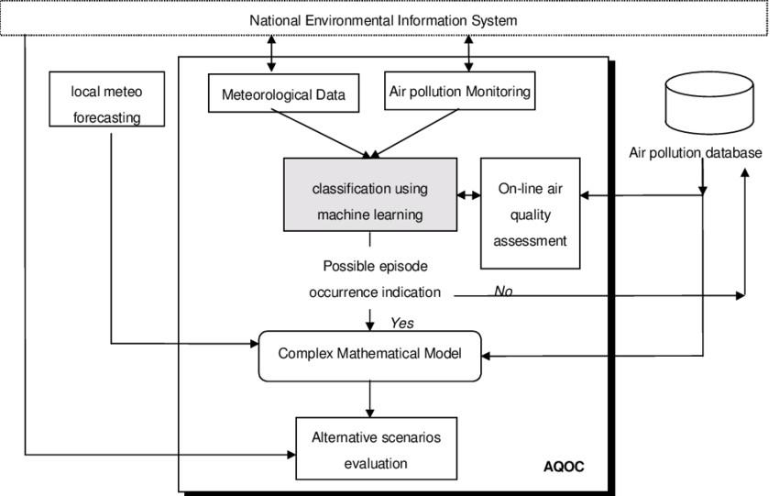

AQI Quality Index:-
The air quality index is an index for reporting air quality on a daily basis. In other words, it is a measure of how air pollution affects one’s health within a short time period.
The AQI is calculated based on the average concentration of a particular pollutant measured over a standard time interval. Generally, the time interval is 24 hours for most pollutants, and 8 hours for carbon monoxide and ozone.
AQI LEVEL | AQI RANGE
Good | 0-50
Moderate | 51-100
Unhealthy | 101-150
Unhealthy for Strong People | 151-200
Hazardous | 200+

Dataset Column Details:-
They are 10 columns and they are:-
- ➢Stn Code
- ➢State
- ➢City/Down/village
- ➢Location of Monitoring Station
- ➢Agency
- ➢Type of Location
- ➢SO₂
- ➢NO2
- ➢RSPM/PM10
- ➢SPM
Implementation:-
import numpy as np
import pandas as pd
import matplotlib.pyplot as plt
import seaborn as sns
plt.rcParams['figure.figsize'] = (10, 7)
import warnings
warnings.filterwarnings('ignore')
import os
print(os.listdir("../input"))
data=pd.read_csv('../input/india-air-quality-data/data.csv',encoding="ISO-8859-1")
data.fillna(0, inplace=True)
data.head()

Output:-
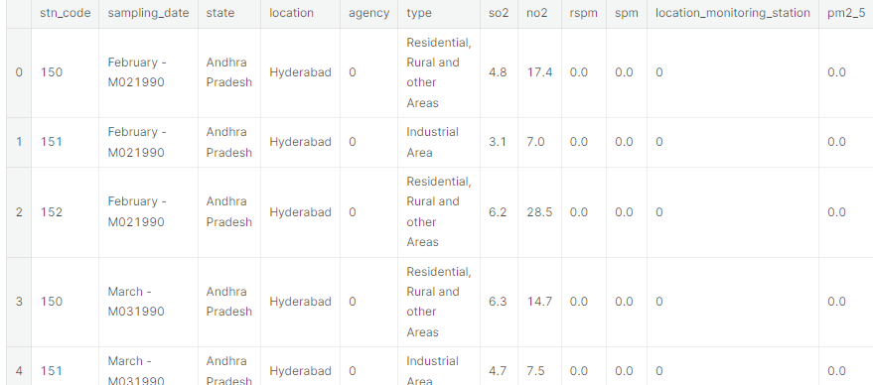

Begin building the project by loading the dataset:-

To load the dataset into Python, we can use the Pandas library:

```python
import pandas as pd

# Load the dataset into a Pandas DataFrame
df = pd.read_csv('filename-location-wise-daily-ambient-air-quality-tamil-nadu-year-2014.csv')

The air Quality Analysis and Prediction project by providing some guidance on loading a dataset. However, I would need more specific information about the dataset you're working with, such as its format (e.g., CSV, JSON, SQL database), where it's located (local file, URL, database), and what programming language or tools you plan to use for this task.

Missing Data:-
Check for missing values and decide how to handle them. You can either impute missing values using methods like mean, median, or use more advanced imputation techniques.
Remove duplicate records if any possibilities.

Outliers:-
Check for outliers, and consider whether to remove them or transform the data to handle extreme values.

Data Integration:-
Merge data from different monitoring stations and sources into a single dataset if applicable.
Ensure that the data from different sources are on a common time scale.

Data Transformation:-
Convert the time/date columns to a datetime format.
Aggregate the data over different time intervals (e.g., daily, monthly) if required.
Create additional features, such as calculating air quality indices like Air Quality Index (AQI).

Feature Engineering:-
Extract relevant features from the data, such as the day of the week, hour of the day, and public holidays, which can influence air quality.
Consider the geographical factors that might affect air quality, like the distance to industrial areas, traffic, or green spaces.

Data Normalization/Scaling:-
Normalize or scale numerical features if necessary to bring all features to a similar scale. Common methods include Min-Max scaling or Z-score normalization.

Splitting the Data:-
sklearn.model_selection.train_test_split(*arrays, test_size=None, train_size=None, random_state=None,
shuffle=True, stratify=None

Preprocess Dataset:-
Once the dataset is loaded, we need to preprocess it before we can begin our analysis. This may involve the following steps:

- Handling missing values:-
If there are any missing values in the dataset, we need to decide how to handle them. We can either drop the rows with missing values, impute the missing values, or create a new feature to indicate whether or not a value is missing.

- Converting data types:-
We may need to convert the data types of some variables to make them more compatible with our analysis. For example, we may want to convert dates to date time objects and numerical variables to floats.

- Creating new features:-
We may want to create new features from the existing features in the dataset. For example, we could create a feature for the average daily air quality index (AQI) or the maximum daily AQI.

Test Data:-
import numpy as np
Import pandas as pd
import matplotlib.pyplot as plt
import seaborn as sns
plt.rcParams['figure.figsize'] = (10, 7)
import warnings
warnings.filterwarnings('ignore')
import os
print(os.listdir("../input"))
data=pd.read_csv(“C:\Users\ELCOT\Downloads\datafile.csv”)
data.fillna(0, inplace=True)
data.head()

Output:-

def calculate_aqi(si,ni,spi,rpi):
aqi=0
if(si>ni and si>spi and si>rpi):
aqi=si
if(spi>si and spi>ni and spi>rpi):
aqi=spi
if(ni>si and ni>spi and ni>rpi):
aqi=ni
if(rpi>si and rpi>ni and rpi>spi):
aqi=rpi
return aqidata['AQI']=data.apply(lambdax:calculate_aqi(x['si'],x['ni'],x['spi'],x['rpi']),axis=1)
df=data[['sampling_date','state','si','ni','rpi','spi','AQI']]
df.head()

Output:-
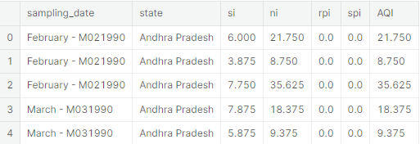
Train Data:-
import numpy as np
import pandas as pd
import matplotlib as plt
import seaborn as sns
data=pd.read_csv(“C:\Users\ELCOT\Downloads\India_Air_Quality_Data_For_TamilNadu.csv”)
longitudes = dff["lon"].tolist()
latitudes = dff["lat"].tolist()
x,y = m(longitudes,latitudes)
fig = plt.figure(figsize=(12,10))
plt.title("All affected areas")
m.plot(x, y, "o", markersize = 3, color = 'blue')
m.drawcoastlines()
m.fillcontinents(color='coral',lake_color='aqua')
m.drawmapboundary()
m.drawcountries()
plt.show()

Output:-
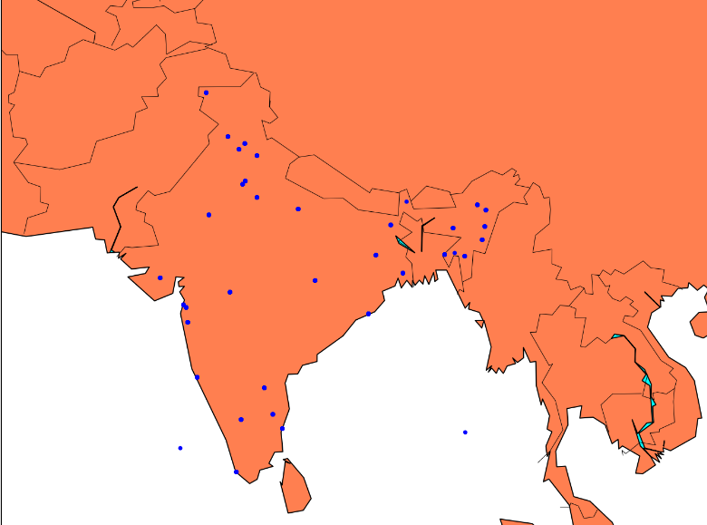

Performing Different Analysis needed:-
Once the dataset is pre processed, we can begin our analysis.
Here are some ideas for different analysis that we could perform:

- Descriptive statistics:-
We can calculate descriptive statistics for the different air quality variables, such as the mean, median, standard deviation, and minimum and maximum values. This will give us a general understanding of the distribution of the data.

- Spatial analysis:-
We can use spatial analysis to visualize the distribution of air quality across Tamil Nadu. This could involve creating maps of the AQI or other air quality variables.

- Temporal analysis:-
We can use temporal analysis to examine how air quality has changed over time. This could involve creating time series plots of the AQI or other air quality variables.

- Predictive analysis:-
We can use machine learning to develop models to predict future air quality levels. This could be useful for developing air quality forecasting systems.

Example of a simple analysis:-
Here is an example of a simple analysis that we could perform on the air quality dataset:
“python”
Calculate the average daily AQI for each location:-
avg_aqi_by_location = df.groupby('Location')['AQI'].mean()

Sort the locations by average AQI:-
avg_aqi_by_location = avg_aqi_by_location.sort_values
(ascending=False)

Print the top 10 locations with the highest average AQI:-
print(avg_aqi_by_location.head(10))

This code will print the top 10 locations in Tamil Nadu with the highest average AQI in 2014.

More complex analysis:-
We can perform more complex analysis on the air quality dataset using machine learning techniques. For example, we could develop a model to predict the future AQI levels for a given location. This could be useful for developing air quality forecasting systems.

To develop a predictive model, we would first need to split the dataset into a training set and a test set. We would then train a machine learning model on the training set and evaluate its performance on the test set. Once the model is trained, we can use it to predict the future AQI levels for a given location.

Conclusion:-
The air quality dataset for Tamil Nadu in the year 2014 can be used to perform a variety of different analyses. We can use descriptive statistics, spatial analysis, temporal analysis, and predictive analysis to learn more about the distribution of air quality across Tamil Nadu and how it has changed over time. We can also use the dataset to develop models to predict future air quality levels.

